1. Create a function module to import a range of customer numbers and export the customer data for the given range.

Customer Data can be found in table KNA1.

Time : 30 minutes

Create a package and keep all objects created for this task in that package.

Paste screenshots of all the objects created for this task.

Package name: zmar_global

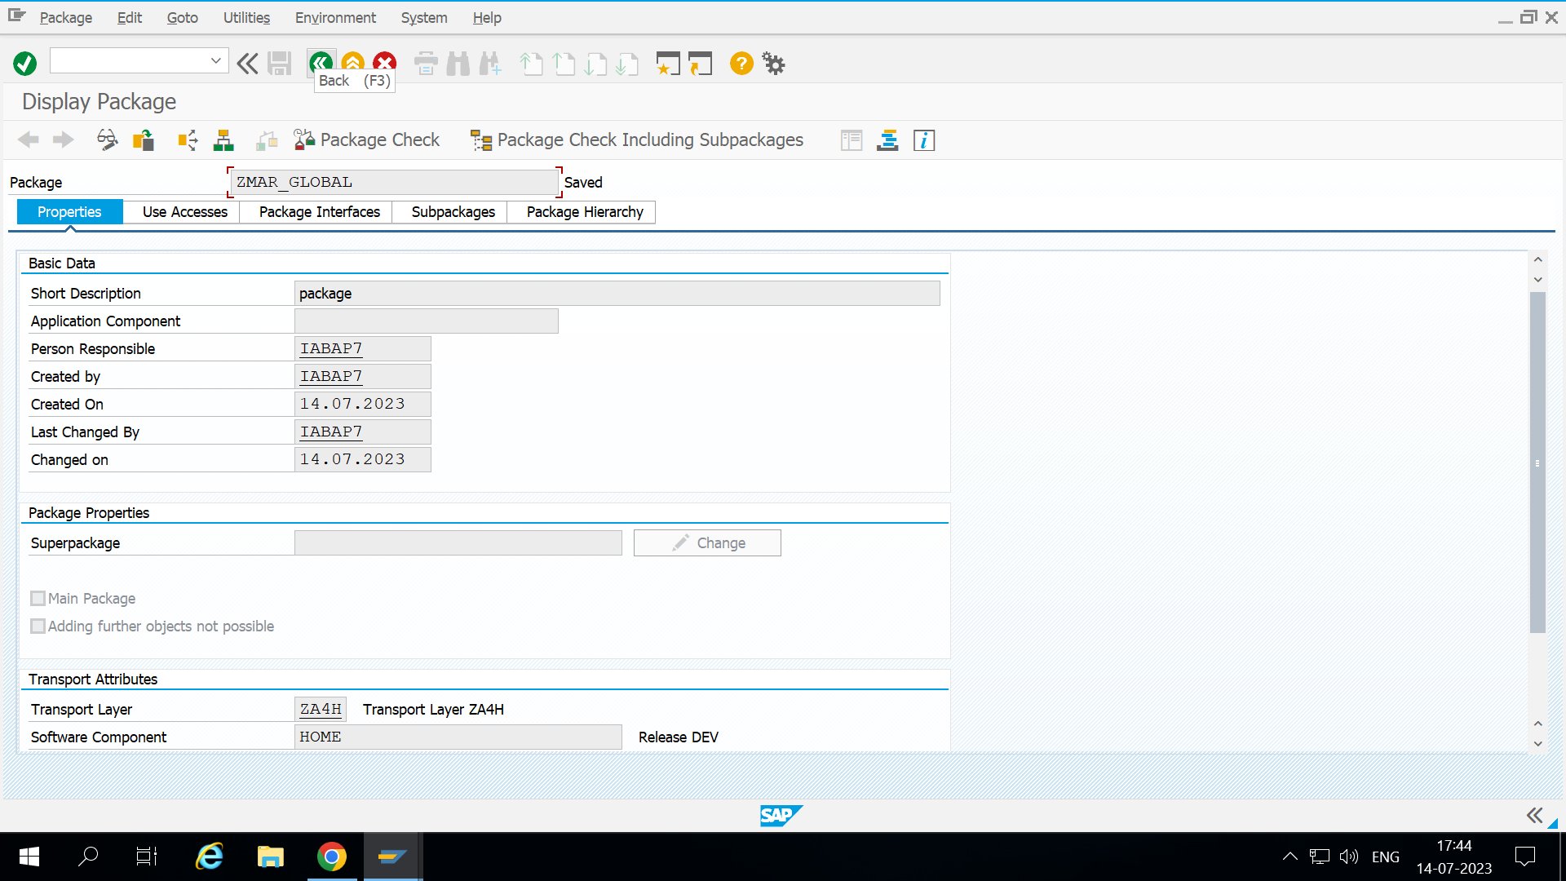Function group : zmar_task1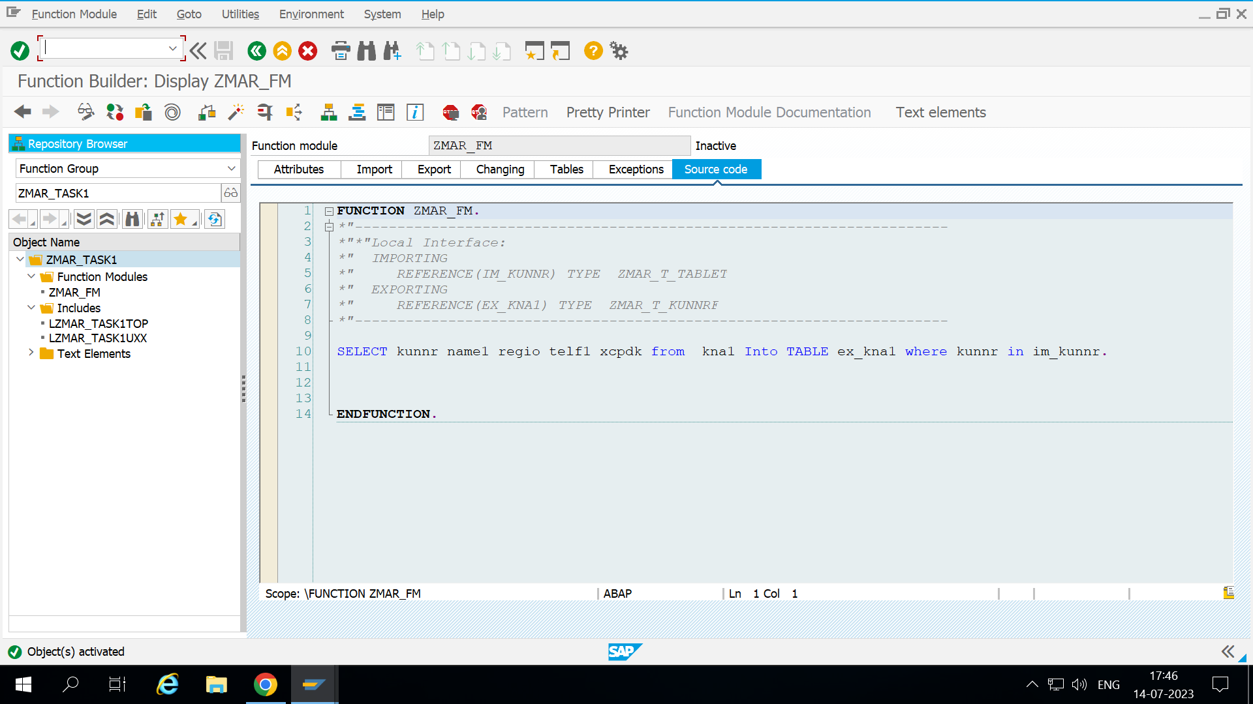

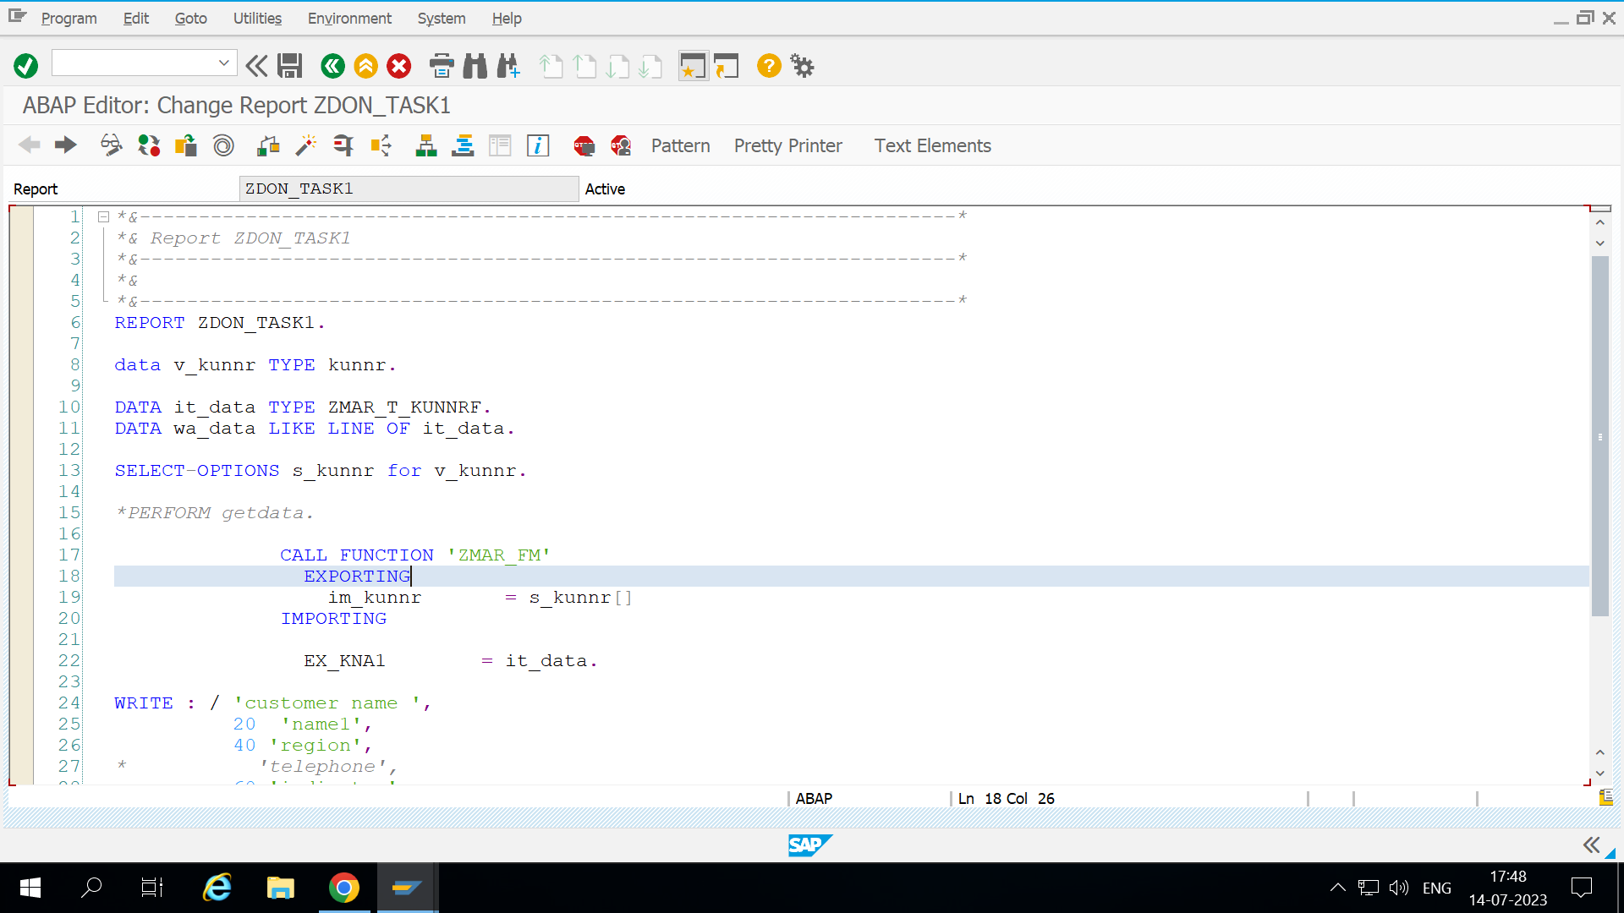

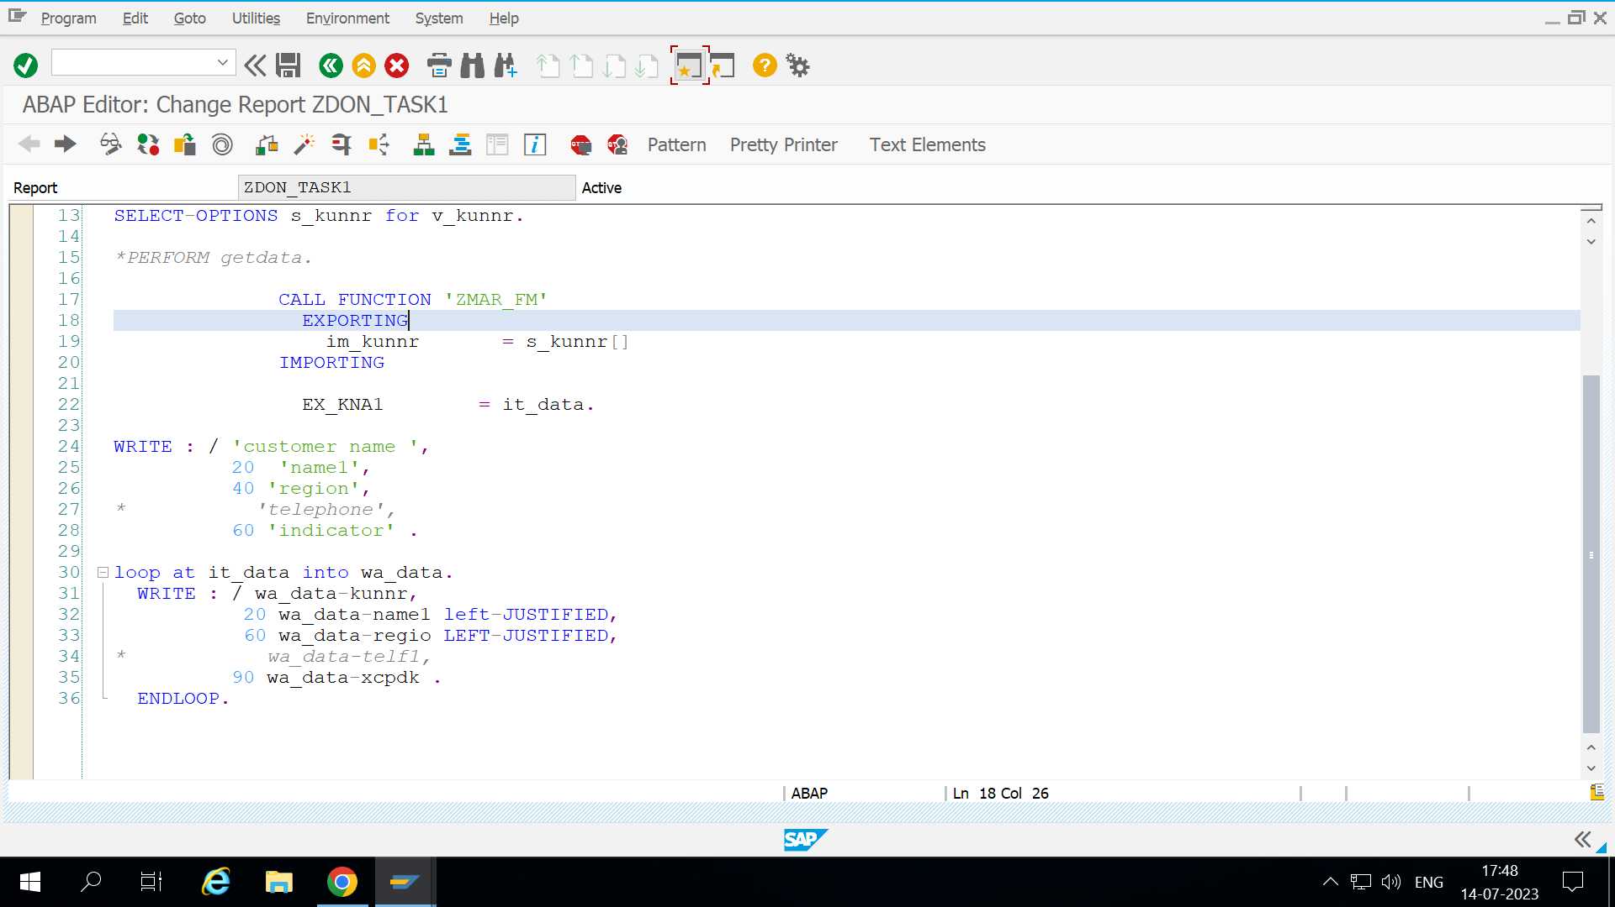

Output:

